PUBLIC HEALTH DYNAMICS LABORATORY
2015-2016 SEMINAR SERIES

Monday, March 14, 2016
12:00 – 1:00 pm
109 Parran Hall

“Transmission Dynamics and Disease Burden of Influenza”

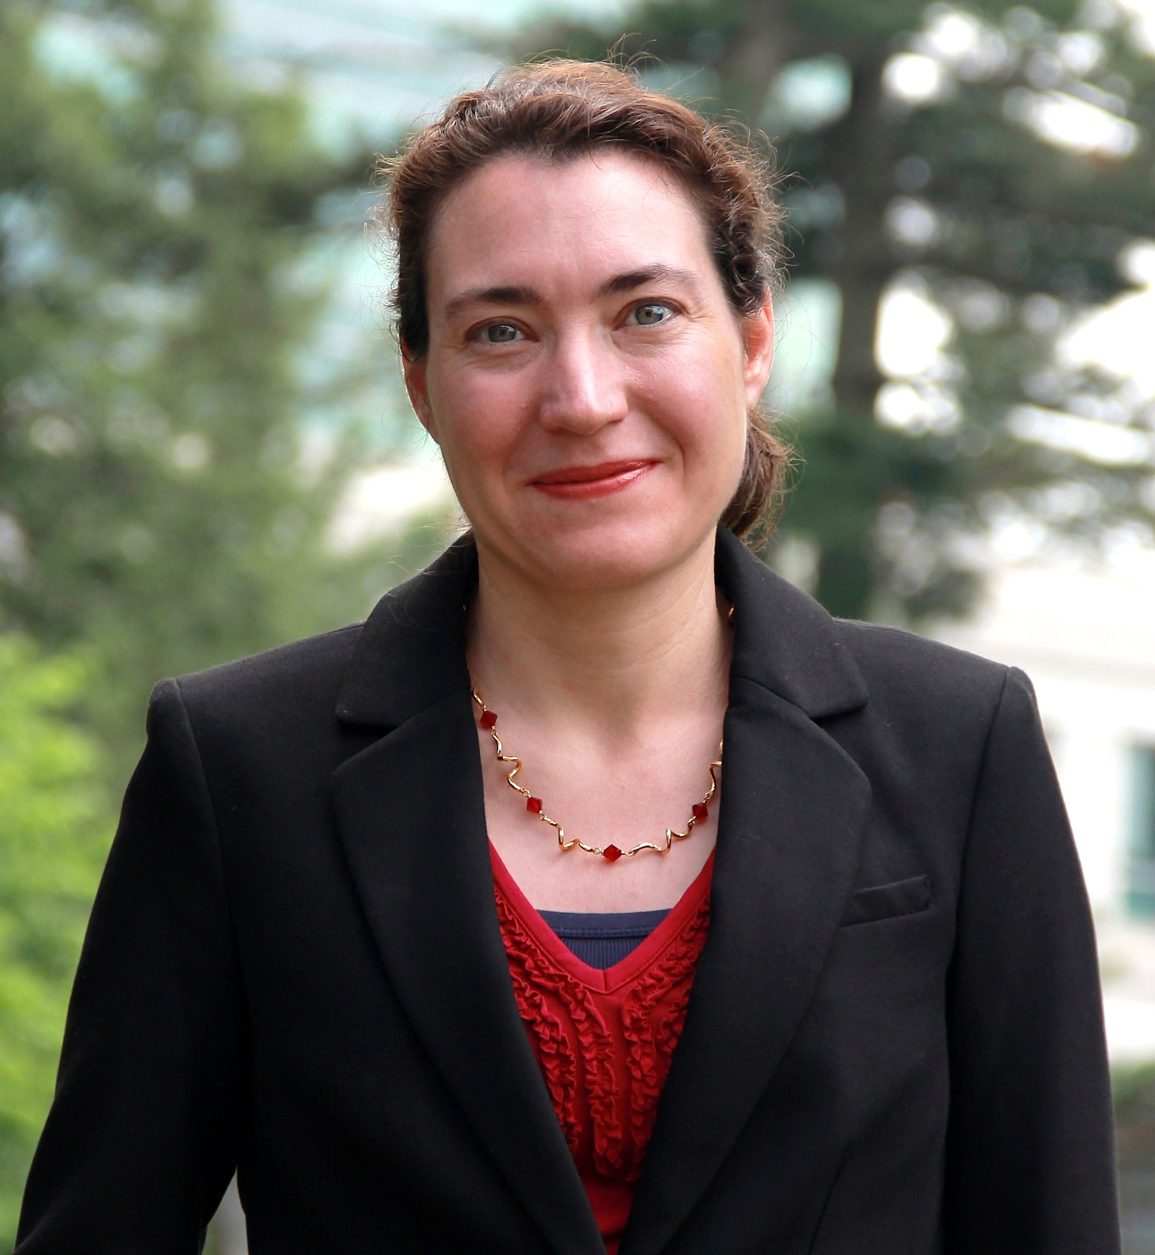
Cécile Viboud, PhD
Division of International Epidemiology and Population Studies
Fogarty International Center
National Institutes of Health

